**Multivariate Analysis for Forecasting the US Unemployment Rate:**

**A Comparative Study of Time Series Models**

**(VAR, ARIMA, Dynamic Regression)**

**Link Github : https://github.com/axeltanjung/us_unemployment_forecast.git**

1. **Introduction & Background**
2. **Introduction**

Understanding the dynamics of the labor market and predicting future unemployment rates is crucial for economic policy making, social welfare programs, and individual career planning. Accurately forecasting unemployment provides insights into the overall health of the economy, allowing policymakers to implement appropriate measures to combat recessions and promote job creation.

Traditionally, univariate time series models, such as ARIMA (Autoregressive Integrated Moving Average), have been the mainstay for unemployment rate forecasting. However, with the increasing complexity of economic systems and the presence of multiple interrelated factors influencing unemployment, multivariate analysis has emerged as a powerful alternative.

This study aims to delve into the world of multivariate analysis for forecasting the US unemployment rate. We will compare and contrast three prominent multivariate models:

* **Vector Autoregressive (VAR) Model:**

This model captures the dynamic interdependencies between multiple time series variables, like inflation, GDP, and interest rates, to predict unemployment.

* **ARIMA-GARCH Model:**

This model combines the strengths of ARIMA for capturing time series trends with GARCH (Generalized Autoregressive Conditional Heteroskedasticity) to account for volatility in the unemployment rate.

* **Dynamic Regression Model:**

This model directly regresses the unemployment rate on various economic and demographic factors, allowing for the interpretation of their individual impacts.

By investigating the performance of these models on historical US unemployment data, we aim to:

* Identify the model that provides the most accurate and reliable forecasts.
* Uncover the role of different economic and demographic factors in influencing unemployment dynamics.
* Provide valuable insights for policymakers and individuals seeking to understand and navigate the complexities of the US labor market.

Beyond a simple comparison of predictive accuracy, this study will delve deeper into the theoretical underpinnings and practical considerations of each model. We will discuss their strengths and weaknesses, data requirements, and interpretability of results. This comprehensive analysis will equip readers with a nuanced understanding of how multivariate analysis can be applied to improve unemployment rate forecasting and shed light on the intricate relationships within the US labor market.

Furthermore, we will explore potential extensions and future research directions in this field. This could involve incorporating additional variables like technological advancements, globalization trends, or policy interventions to further refine forecasts and enhance our understanding of unemployment dynamics.

In conclusion, this study promises to be a valuable contribution to the field of labor economics and forecasting. By employing multivariate analysis and comparing various models, we hope to provide new insights into unemployment dynamics and equip policymakers and individuals with the tools necessary to navigate the ever-changing US labor market.

**B. Business Context**

In today's dynamic business environment, accurately anticipating fluctuations in the US unemployment rate is not just an academic exercise, but a critical tool for driving profitability and competitiveness. Businesses across various sectors stand to gain significant advantages from reliable unemployment forecasts:

* **Human Resources & Talent Acquisition**

Precisely predicting future labor market conditions allows companies to strategically plan their workforce needs, optimize recruitment efforts, and negotiate competitive compensation packages.

* **Financial Services & Investment**

Accurate unemployment forecasts inform crucial investment decisions, risk management strategies, and product development within the financial sector. Anticipating shifts in unemployment trends can help banks adjust lending practices, insurance companies refine risk assessments, and investment firms refine portfolio allocations.

* **Retail & Consumer Goods**

Businesses catering to consumers' needs can leverage unemployment forecasts to tailor their product offerings, pricing strategies, and marketing campaigns based on anticipated changes in disposable income and spending patterns.

* **Manufacturing & Supply Chain Management**

Accurately predicting labor availability in key production regions enables manufacturers to optimize production schedules, manage supply chains, and minimize disruptions caused by potential labor shortages.

Beyond individual businesses, reliable unemployment forecasts are vital for broader economic stability and policy planning:

* **Government Policy & Intervention**

Governments heavily rely on accurate unemployment data to formulate effective fiscal and monetary policies. Precise forecasts inform decisions on unemployment benefits, infrastructure spending, and job training programs, fostering a stable and thriving economy.

* **Social Welfare Programs**

Anticipating changes in unemployment helps social welfare agencies allocate resources efficiently, ensuring timely support for individuals who lose their jobs and mitigating the negative impacts of economic downturns.

In conclusion, the accurate forecasting of the US unemployment rate is not merely an academic pursuit, but a critical tool for businesses, policymakers, and society as a whole. By employing advanced multivariate analysis techniques like those explored in this study, we can gain valuable insights into the complex dynamics of the US labor market and make informed decisions that drive economic growth, stability, and well-being.

1. **Business Objective**

**Key Objectives for Businesses:**

**Optimize Workforce Planning and Recruitment:**

* Accurately forecast labor supply and demand to align hiring strategies with anticipated needs.
* Identify skill shortages and target recruitment efforts accordingly.
* Anticipate wage trends and negotiate competitive compensation packages.

**Enhance Financial Risk Management:**

* Assess the impact of unemployment fluctuations on credit risk and loan defaults.
* Develop proactive strategies to mitigate potential losses and maintain financial stability.
* Adjust investment portfolios based on anticipated economic shifts.

**Optimize Pricing, Marketing, and Product Development:**

* Understand the influence of unemployment on consumer spending patterns and preferences.
* Adjust pricing strategies and product offerings to meet evolving needs in different economic conditions.
* Target marketing campaigns effectively to reach customers with varying levels of disposable income.

**Improve Supply Chain Resilience:**

* Anticipate potential labor shortages in key production regions and adjust supply chains accordingly.
* Optimize production schedules and inventory management to minimize disruptions.
* Develop contingency plans to maintain operations during economic downturns.

**Key Objectives for Government and Social Welfare:**

**Formulate Effective Economic and Labor Policies:**

* Design targeted job training programs to address skill gaps and emerging industries.
* Allocate resources for unemployment benefits and social support programs efficiently.
* Implement timely fiscal and monetary policies to stabilize the economy during recessions.

**Enhance Social Welfare Programs:**

* Predict future unemployment trends to anticipate demand for social services.
* Allocate resources effectively to support individuals and families facing job loss.
* Develop proactive measures to mitigate the negative impacts of unemployment on communities.

1. **Dataset & Features**

For create the analysis, we use the dataset with features as follows

* + - **Observation_date** : Represents the date of the observation Quarterly since 1948 - 2023
    - **Unemploy** : Represents total unemployment (Thousands of Persons) Quarterly

The Unemployment Level is the aggregate measure of people currently unemployed in the US. Someone in the labor force is defined as unemployed if they were not employed during the survey reference week, were available for work, and made at least one active effort to find a job during the 4-week survey period.

The Unemployment Level is collected in the CPS and published by the BLS. It is provided on a monthly basis, so this data is used in part by macroeconomists as an initial economic indicator of current trends. The Unemployment Level helps government agencies, financial markets, and researchers gauge the overall health of the economy.

Note that individuals that are not employed but not actively looking for a job are not counted as unemployed. For instance, declines in the Unemployment Level may either reflect movements of unemployed individuals into the labor force because they found a job, or movements of unemployed individuals out of the labor force because they stopped looking to find a job.

* + - **GDP** : Represents the Gross Domestic Product (GDP) (Billions of Dollars) Quarterly)

BEA Account Code: A191RC

Gross domestic product (GDP), the featured measure of U.S. output, is the market value of the goods and services produced by labor and property located in the United States.For more information, see the Guide to the National Income and Product Accounts of the United States (NIPA) and the Bureau of Economic Analysis.

* + - **CPIAUSCL** : Represents the The Customer Price Index Quarterly

The Consumer Price Index for All Urban Consumers: All Items (CPIAUCSL) is a price index of a basket of goods and services paid by urban consumers. Percent changes in the price index measure the inflation rate between any two time periods. The most common inflation metric is the percent change from one year ago. It can also represent the buying habits of urban consumers. This particular index includes roughly 88 percent of the total population, accounting for wage earners, clerical workers, technical workers, self-employed, short-term workers, unemployed, retirees, and those not in the labor force.

The CPIs are based on prices for food, clothing, shelter, and fuels; transportation fares; service fees (e.g., water and sewer service); and sales taxes. Prices are collected monthly from about 4,000 housing units and approximately 26,000 retail establishments across 87 urban areas. To calculate the index, price changes are averaged with weights representing their importance in the spending of the particular group. The index measures price changes (as a percent change) from a predetermined reference date. In addition to the original unadjusted index distributed, the Bureau of Labor Statistics also releases a seasonally adjusted index. The unadjusted series reflects all factors that may influence a change in prices. However, it can be very useful to look at the seasonally adjusted CPI, which removes the effects of seasonal changes, such as weather, school year, production cycles, and holidays.

The CPI can be used to recognize periods of inflation and deflation. Significant increases in the CPI within a short time frame might indicate a period of inflation, and significant decreases in CPI within a short time frame might indicate a period of deflation. However, because the CPI includes volatile food and oil prices, it might not be a reliable measure of inflationary and deflationary periods. For a more accurate detection, the core CPI (CPILFESL) is often used. When using the CPI, please note that it is not applicable to all consumers and should not be used to determine relative living costs. Additionally, the CPI is a statistical measure vulnerable to sampling error since it is based on a sample of prices and not the complete average.

Source of original dataset can be access through this link:

<https://fred.stlouisfed.org/series/UNEMPLOY>

<https://fred.stlouisfed.org/series/GDP>

https://fred.stlouisfed.org/series/CPIAUCSL#0

1. **Data Preparation and Exploratory Data Analysis**

The data acquisition process plays a critical role in the development of the credit scoring model for the Credit Card Product division of Amara Bank. The following are the key components involved in the data acquisition stage:

1. **Data Acquisition**

**Application Form:**

The application form serves as a primary source of customer-provided data, capturing essential information such as personal details, employment history, income, and other relevant financial information. This data provides insights into the applicant's financial standing, employment stability, and credit requirements, forming the initial dataset for the credit evaluation process.

**Credit Bureau:**

The Credit Bureau data encompasses information obtained from various external sources, including SLIK (Sistem Layanan Informasi Keuangan), BI Checking (Bank Indonesia Checking), and APPI Checking (Asosiasi Perusahaan Pembiayaan Indonesia Checking). These sources provide comprehensive credit information, including the applicant's credit history, outstanding debts, existing credit accounts, and repayment patterns, enabling a thorough assessment of the applicant's creditworthiness and risk profile.

**Internal System - Behavioral Data:**

Behavioral data obtained from internal systems includes a comprehensive record of the applicant's interactions with Amara Bank, particularly within the Credit Card Product division. This data encompasses the applicant's historical credit card usage patterns, transactional behavior, repayment history, and any instances of repeat or additional orders. The analysis of this data provides valuable insights into the applicant's credit utilization habits and repayment discipline, contributing to a holistic assessment of the applicant's credit risk profile.

**Performance Data:**

Performance data refers to the outcome data associated with each credit application, encompassing critical information such as the applicant's payment history, instances of default, frequency of late payments, and any history of delinquency. This data enables the division to assess the applicant's credit performance and behavior, facilitating the identification of potential high-risk applicants and the establishment of risk mitigation strategies to minimize the incidence of non-performing loans and defaults within the credit card portfolio.

By effectively acquiring and analyzing these diverse data sources, the Credit Card Product division of Amara Bank can construct a comprehensive and multidimensional dataset, laying the groundwork for the subsequent development and implementation of the credit scoring model using Logistic Regression.

1. **Good/Bad Definition**

**Observation/Selection Statuses:**

**Observation Exclude:**

This status involves the exclusion of certain observations from the dataset, primarily to address sample bias issues. These exclusions may arise due to data inconsistencies, data quality issues, or other sample selection biases that could potentially skew the analysis and compromise the accuracy of the credit scoring model.

**Reject:**

The 'Reject' status refers to cases where applicants are not selected for credit approval, as determined by the lender. These cases represent instances where the lender deems the applicant to be ineligible for credit, typically due to factors such as a high-risk profile, poor credit history, or inadequate financial standing.

**Not Taken Up (NTU):**

'Not Taken Up' signifies cases where applicants are selected for credit but do not proceed with the credit facility, despite being approved by the lender. This status often arises when the borrower chooses not to utilize the credit product, even after meeting the lender's criteria for approval.

**Mutual Accept:**

'Mutual Accept' represents cases where the selected applicants have accepted and utilized the credit facility provided by the lender, either responsibly or in a manner that indicates potential credit misuse or abuse.

**Outcome/Performance Statuses:**

**Good:**

The 'Good' status signifies desirable outcomes, such as timely payments, responsible credit utilization, and a positive credit performance, reflecting a borrower's ability to manage credit responsibly and meet their financial obligations effectively.

**Bad:**

The 'Bad' status refers to undesirable outcomes, including instances of default, delinquency, or any other adverse credit events that indicate a high level of credit risk and potential financial instability.

**Indeterminate:**

The 'Indeterminate' status represents outcomes that fall between the 'Good' and 'Bad' categories, indicating a moderate level of credit risk or uncertainty in the borrower's credit behavior. This optional category allows for the nuanced classification of cases that do not distinctly fit into either the 'Good' or 'Bad' classification.

**Excludes:**

The 'Excludes' category encompasses any outcomes that lie outside the intended scope of the credit scoring model, such as operational-risk events or fraudulent activities that may impact the overall risk assessment but are not directly related to the borrower's credit behavior.

In the final scorecard development, the use of the 'Good' and 'Bad' classifications enables the Credit Card Product division to establish clear benchmarks for evaluating the creditworthiness of applicants, facilitating more accurate risk assessments and informed credit decisions.

1. **Performance and Sample Windows**

**Performance Window:**

The performance window refers to the designated time frame during which the credit performance of accounts is continuously monitored and assessed to assign specific performance targets. This window allows for the evaluation of the borrower's credit behavior over a defined period, enabling the identification of patterns, trends, and potential risks associated with the borrower's repayment patterns and credit utilization habits.

**Sample Window:**

The sample window denotes the specific time frame from which known 'good' and 'bad' cases are selected for the sample dataset. This window serves as the basis for selecting historical data to train and validate the credit scoring model, facilitating the identification of key variables and patterns that contribute to the differentiation between creditworthy and high-risk applicants.

Furthermore, there are several approaches to determining the sample and performance windows, including:

**Basel II:**

This approach, as defined by the Basel II framework, emphasizes the use of historical data and specific time frames to assess credit risk and establish adequate capital requirements, ensuring that financial institutions maintain sufficient capital reserves to cover potential credit losses within a defined time horizon.

**"Decision Horizon" Approach from IFRS 9:**

The "Decision Horizon" approach, as outlined by the International Financial Reporting Standards (IFRS) 9, emphasizes the evaluation of the credit performance of accounts within a specific time frame to assess expected credit losses accurately and facilitate effective risk management practices within the banking sector.

**Portfolio Maturity Using Cohort/Vintage Analysis:**

This approach involves the analysis of portfolio maturity through cohort or vintage analysis, enabling the identification of specific cohorts or groups of accounts with similar origination dates to assess their credit performance and behavior over time. This analysis aids in the understanding of the credit risk dynamics associated with different borrower segments within the portfolio.

By leveraging these diverse approaches, the Credit Card Product division of Amara Bank can effectively determine the performance and sample windows, enabling the accurate assessment of credit risk, the identification of key trends, and the development of a robust credit scoring model tailored to the unique dynamics of the credit card market.

1. **Data Sampling**

**Sample Types:**

**Development Set:**

The development set comprises a significant portion, typically 70 to 80 percent, of the total sample, and is used to construct and develop each scorecard within the credit scoring model. This set allows for the iterative refinement and optimization of the model, enabling the identification of key variables and patterns that contribute to the accurate differentiation between 'good' and 'bad' credit applicants.

**Validation Set:**

The validation set constitutes the remaining 20 to 30 percent of the sample and is utilized to independently test and validate the performance and predictive accuracy of the scorecard. This set enables the division to assess the model's generalizability and robustness, ensuring that the developed model exhibits consistent performance and accuracy across diverse datasets and real-world scenarios.

**Sample Sizes:**

According to Anderson, the literature on credit scoring recommends a minimum sample size of:

1,500 'bads'

1,500 'goods'

1,000 'rejects'

These sample size requirements ensure an adequate representation of both high-risk and low-risk credit applicants, as well as rejected applicants, facilitating a comprehensive analysis of the credit risk dynamics within the Credit Card Product division's portfolio.

**Sampling Methods:**

**Simple Random Sample:**

The simple random sampling method involves the random selection of observations from the population, ensuring that each element within the population has an equal chance of being selected for the sample. This method enables the division to obtain a representative sample and minimize potential sampling biases or distortions within the dataset.

**Stratified Random Sample:**

The stratified random sampling method involves the division of the population into distinct strata or subgroups based on specific characteristics or attributes, followed by the random selection of observations from each stratum. This method allows for the representation of diverse borrower segments within the sample, ensuring that the model adequately captures the unique credit risk profiles of different customer segments.

By leveraging these sample types, sample sizes, and sampling methods, the Credit Card Product division of Amara Bank can construct robust and reliable datasets for the development and validation of the credit scoring model, facilitating accurate risk assessments and informed credit decision-making within the dynamic credit card market landscape.

In the process of developing a robust credit scoring model for the Credit Card Product division of Amara Bank, preventing leakage of test set information and conducting exploratory data analysis (EDA) on the training set are critical steps to ensure the model's predictive performance on unseen data. The following elaborates on the key actions taken during the EDA phase:

1. **Exploratory Data Analysis (EDA)**

**1. Check Data Integrity:**

Conducting a thorough check of the data integrity within the training set is crucial to identify and address any potential data quality issues or inconsistencies. This step involves verifying the completeness, accuracy, and consistency of the data, ensuring that the dataset is free from any erroneous or misleading information that could impact the model's performance and reliability.

**2. Check for Any Insights in the Data:**

Exploring the distribution, proportion, presence of outliers, and patterns within the training set allows for a comprehensive understanding of the underlying data characteristics. Analyzing the distribution of key variables, identifying any imbalances in the data, detecting outliers, and assessing the extent of missing values provides valuable insights that can guide the subsequent data preprocessing and feature engineering processes.

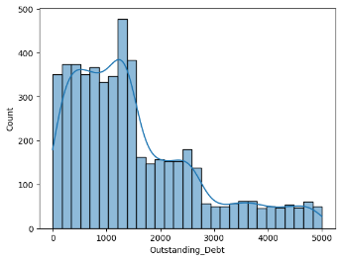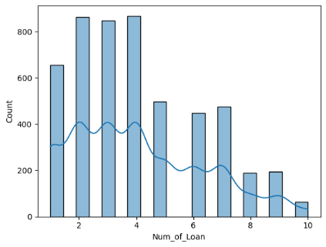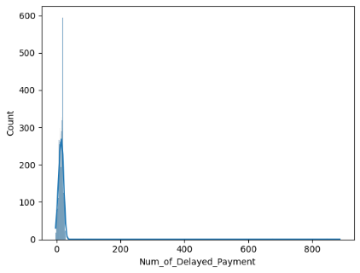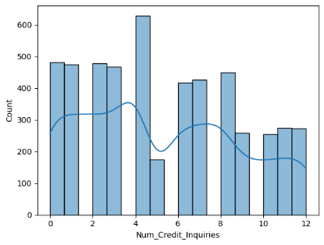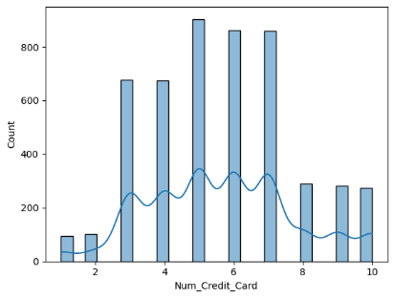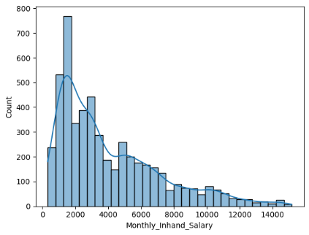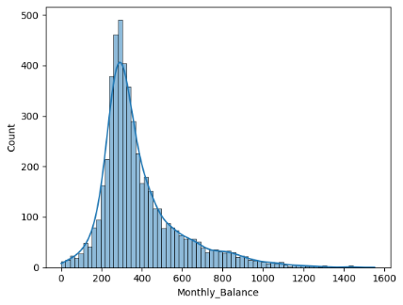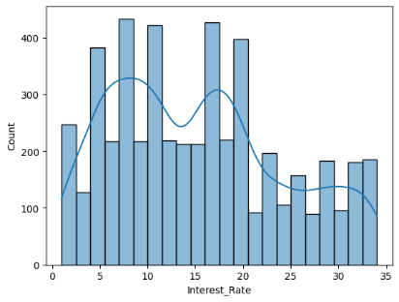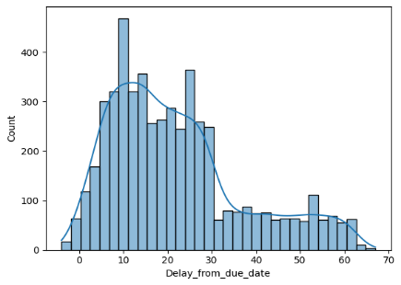

**Distribution Plot of Numerical Predictor**

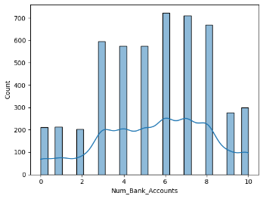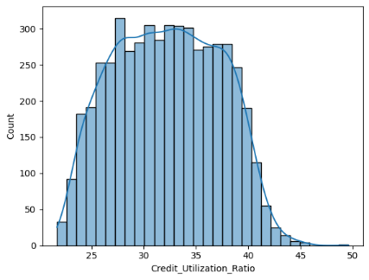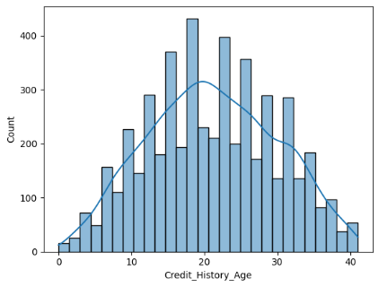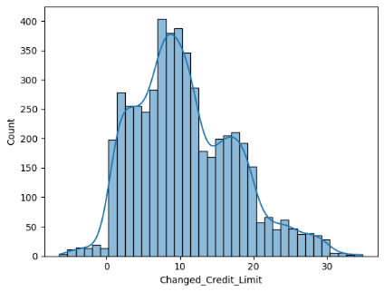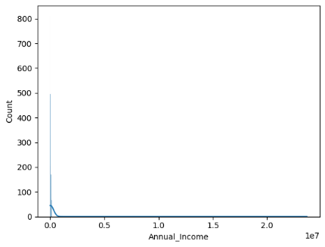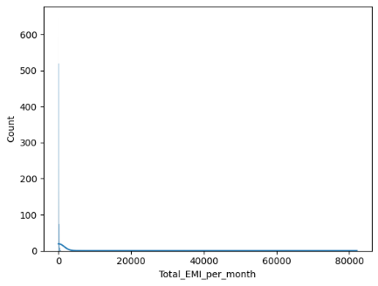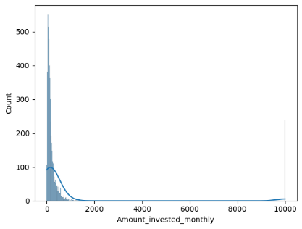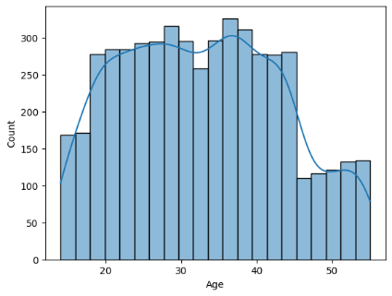

**Distribution Plot of Numerical Predictor**

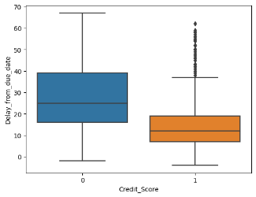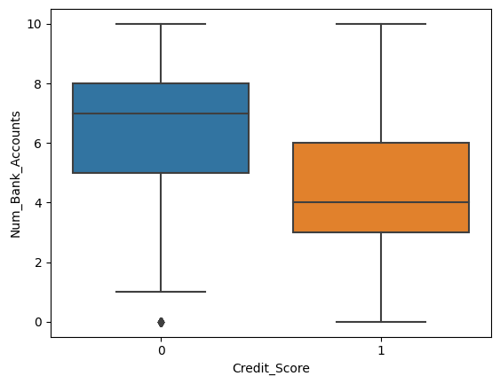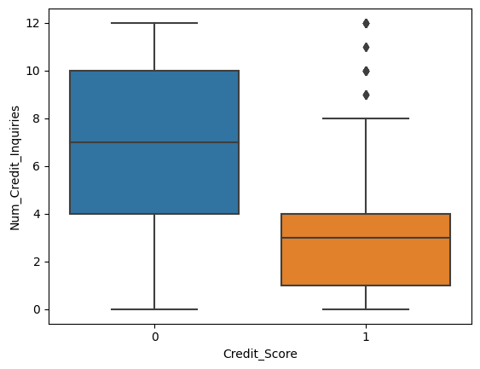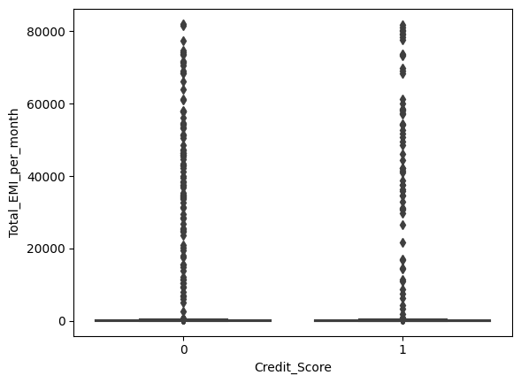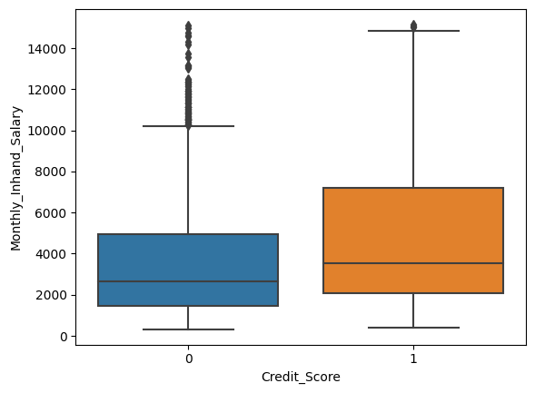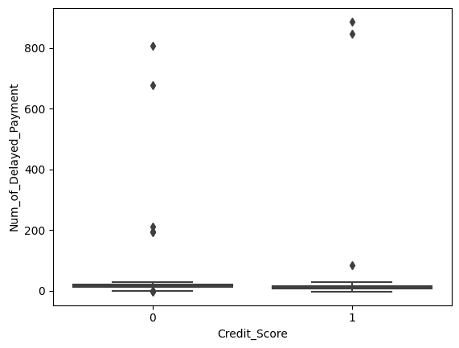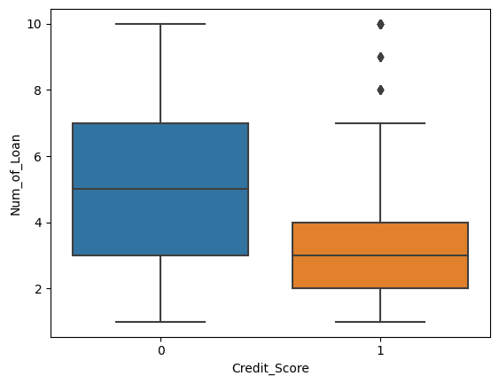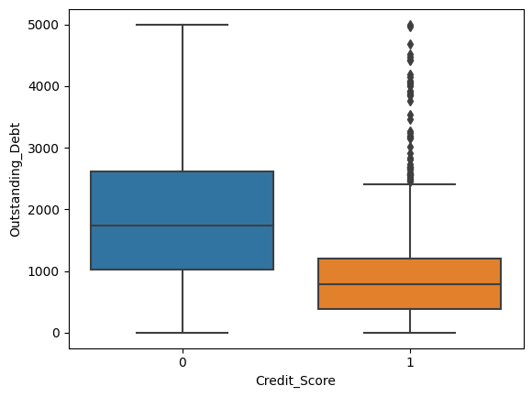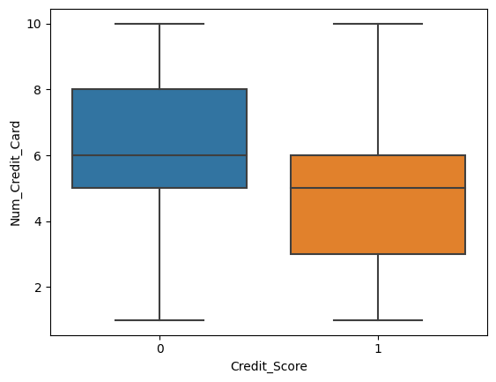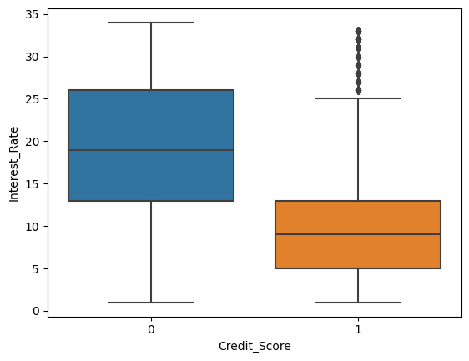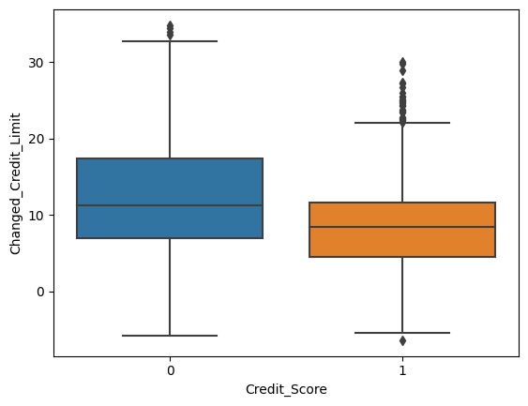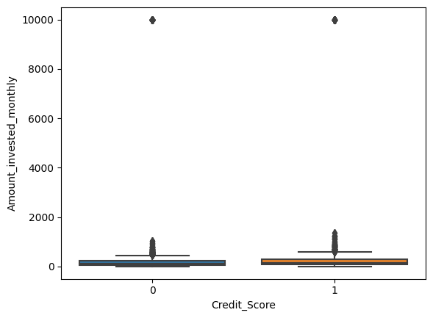

**Box-Plot of Numerical Predictor**

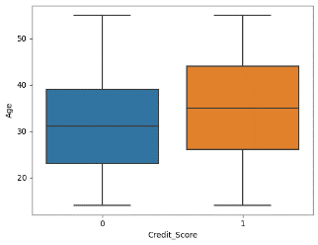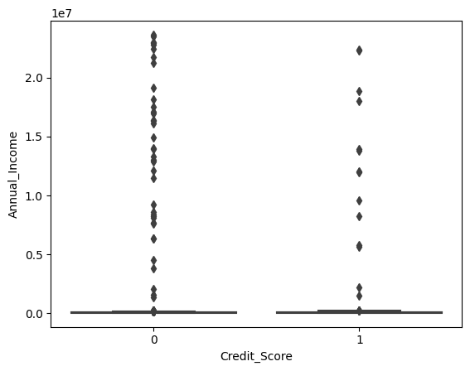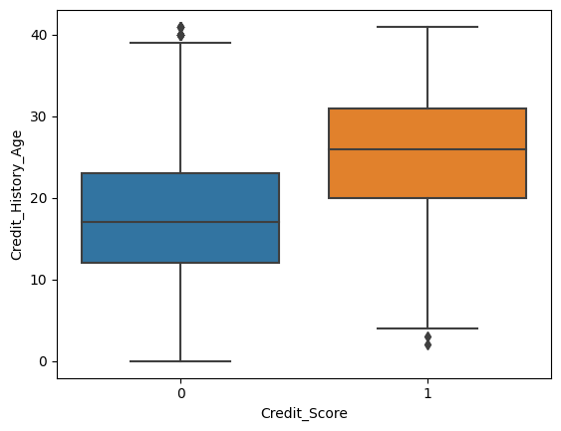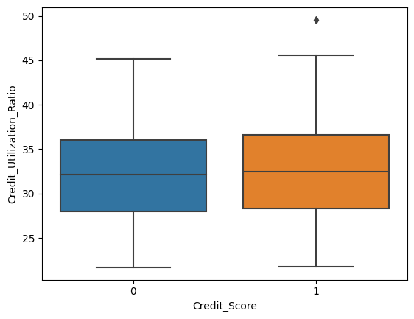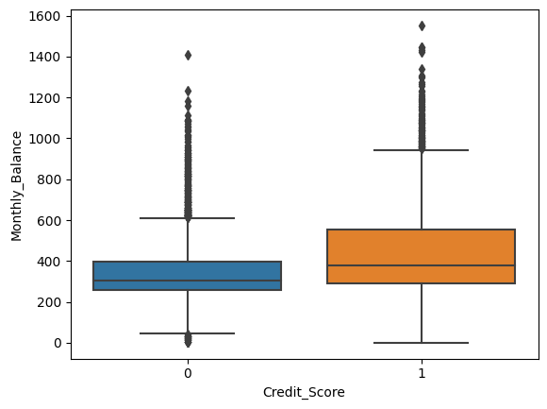

**Box-Plot of Numerical Predictor**

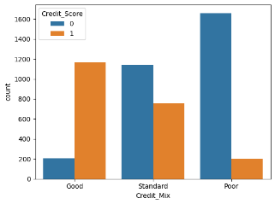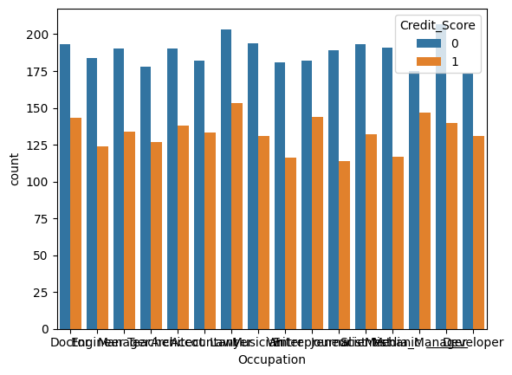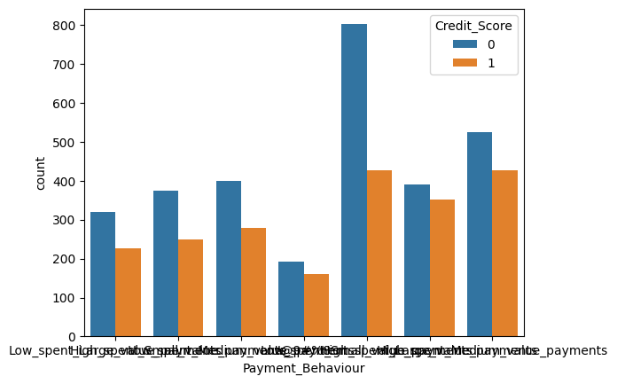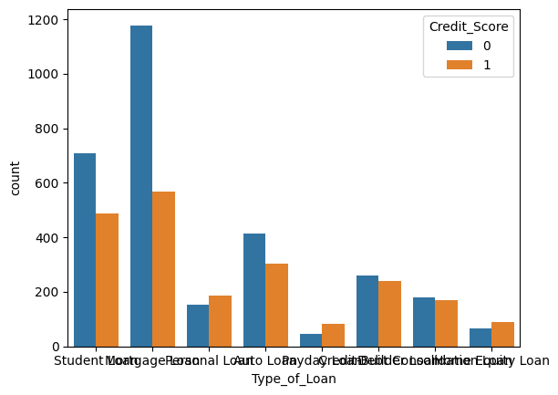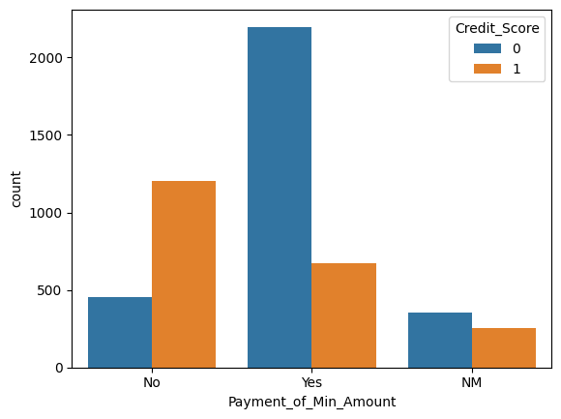

**Statistical Description of Categorical Columns**

**Correlation of Numerical Feature**

**3. Make a Plan for Data Pre-processing:**

Formulating a robust plan for data pre-processing is essential to address data inconsistencies, handle missing values, treat outliers, and standardize the data for effective model training. This plan involves defining the steps for data cleaning, feature scaling, handling missing data through imputation strategies, and implementing data transformation techniques to ensure the data is appropriately structured and optimized for model development.

**Check missing values Check for data type**

There are missing values in `Age`, `Num_Bank_Accounts`, `Num_Credit_Card`, `Interest_Rate`, `Num_of_Loan`, `Num_of_Delayed_Payment`, `Num_Credit_Inquiries` a categorical variable and numerical.

**Splitting dataset input and output**

1. **Initial Characteristic Analysis**
2. **Binning Numerical Characteristics**

Naeem Siddiqi's recommendation advocates for the binning of numerical characteristics into approximately 20 equal groups, each comprising approximately 5 percent of the total accounts. This approach enables the division to categorize and group numerical variables, such as income, credit utilization, or credit scores, into discrete intervals, facilitating a more intuitive and simplified representation of the data distribution and variability.

**Significance of Optimal Binning:**

**Mitigating Complexity and Overfitting:**

The suggested approach emphasizes the importance of balancing the number of bins to mitigate the risk of model overfitting. By limiting the number of bins to a reasonable count, the division can prevent the model from capturing noise or irrelevant patterns within the data, ensuring that the model's predictive capabilities remain focused on the essential information necessary for accurate credit risk assessment.

**Preserving Information:**

The approach highlights the need to avoid an excessively low number of bins, as this can lead to a loss of valuable information and intricacies present within the dataset. By maintaining an optimal number of bins, the division can effectively preserve the essential characteristics and patterns embedded within the data, enabling the model to capture the underlying nuances of the credit risk landscape and make informed and accurate credit decisions.

By leveraging this binning approach, the Credit Card Product division of Amara Bank can effectively simplify the representation of numerical characteristics, reduce data complexity, and enhance the interpretability of the credit scoring model, while preserving the critical information necessary for robust risk assessment and informed credit evaluation. This approach contributes to the development of a more streamlined and reliable credit scoring model tailored to the unique dynamics of the Credit Card Product division's customer base.

Using data_concat function, input (X) and output (y) has been concatenaned. After that, create function to binning the numerical predictors and fill the null value with missing data with define_num_binning and data_bin function.

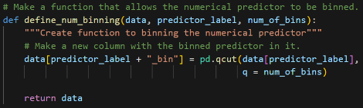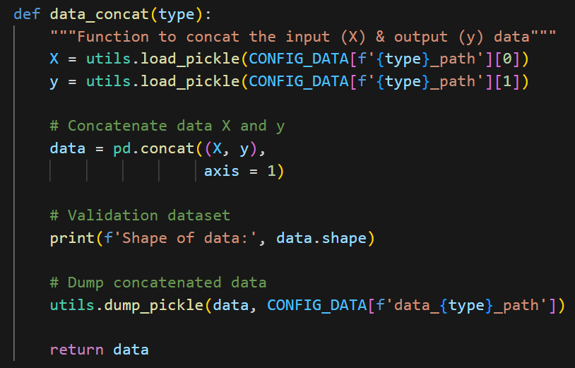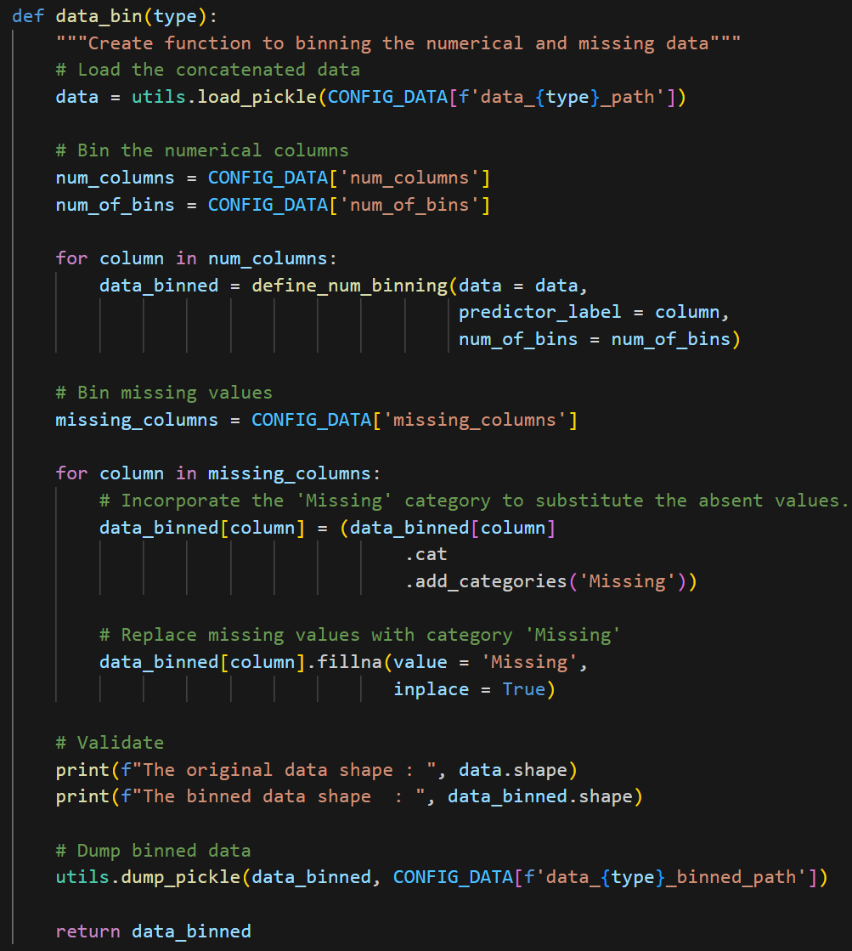

**B. Understanding the Weight of Evidence (WoE):**

**1. Measure of Predictive Power:**

WoE quantifies the predictive power of each attribute by assessing its ability to differentiate between 'good' and 'bad' credit applicants. It calculates the relative likelihood of a specific attribute value leading to either a positive or negative outcome, enabling the division to identify the attributes that significantly influence the credit risk assessment process.

**2. Assessment of Relative Risk:**

WoE facilitates the assessment of the relative risk associated with different attributes within a characteristic. By assigning a numerical value to the relative risk of each attribute, the technique enables the division to prioritize the attributes that have a more substantial impact on the overall credit risk profile, allowing for a more accurate and targeted evaluation of credit applicants.

**3. Contribution to Model Development:**

WoE serves as a fundamental component in the development of the credit scoring model, aiding in the selection of relevant attributes and the construction of the model's predictive framework. By analyzing the WoE values of various attributes, the division can identify the most influential factors driving credit risk, enabling the model to incorporate these attributes effectively and enhance its discriminatory power and accuracy in assessing creditworthiness.

1. **Understanding Information Value (IV)**

* **Comprehensive Strength Measurement:**

IV enables the comprehensive measurement of the total predictive strength of a characteristic, considering all possible values and their respective impact on the predicted outcome. By aggregating the predictive power of individual values within the characteristic, IV provides a holistic assessment of the characteristic's ability to differentiate between 'good' and 'bad' credit applicants, contributing to the overall robustness of the credit scoring model.

* **Quantification of Predictive Relationship:**

IV quantifies the strength of the relationship between the characteristic and the predicted outcome, offering a numerical representation of the characteristic's ability to contribute to the accurate assessment of credit risk. It considers both the magnitude and direction of the relationship, enabling the division to identify the characteristics that significantly influence the model's predictive accuracy and discriminatory power.

* **Contribution to Model Assessment:**

IV plays a pivotal role in the evaluation and assessment of the credit scoring model's efficacy, facilitating the identification of the most impactful characteristics and their relative importance in the credit risk evaluation process. By analyzing the Information Value of various characteristics, the division can prioritize the key drivers of credit risk and refine the model's predictive framework to enhance its accuracy and reliability in predicting creditworthiness.

To evaluate each trait's strength separately as a predictor of credit performance. Create function define_crosstab_list that (contingency table) needed for the computation of WOE and IV in training data only.

**Example of crosstab_list**

After that, create function to calculate Information Value and Weight of Evidence as follows:

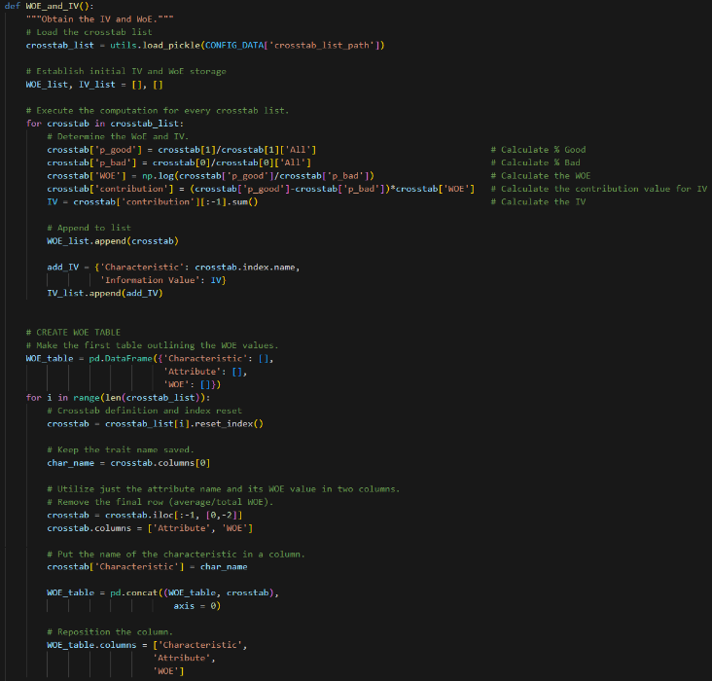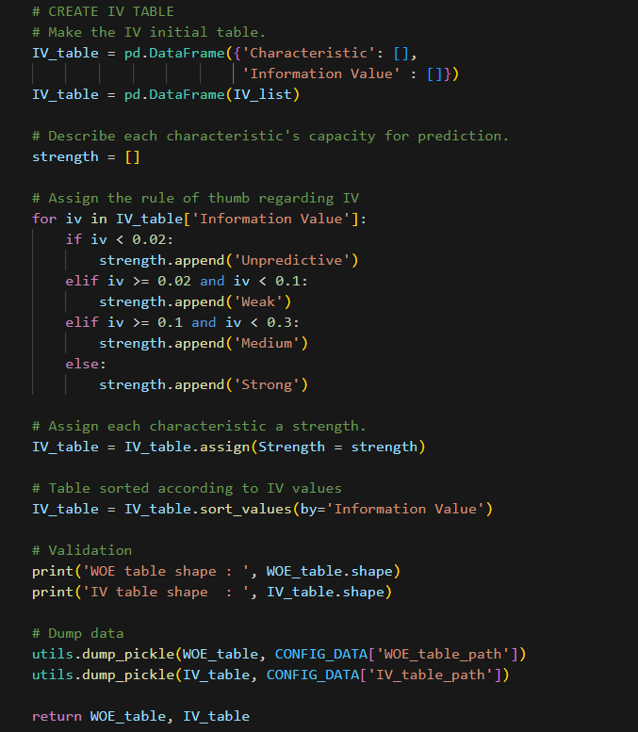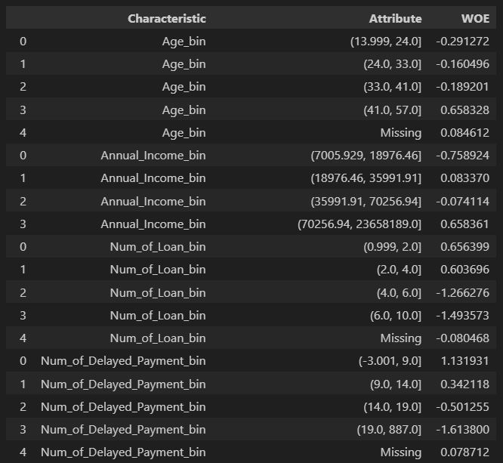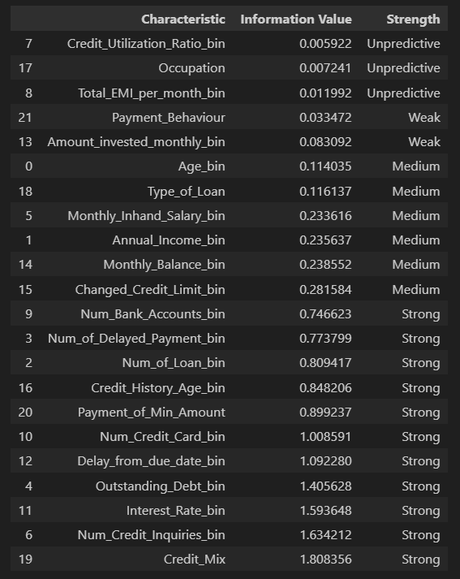

**Value of WoE and IV for each Characteristic**

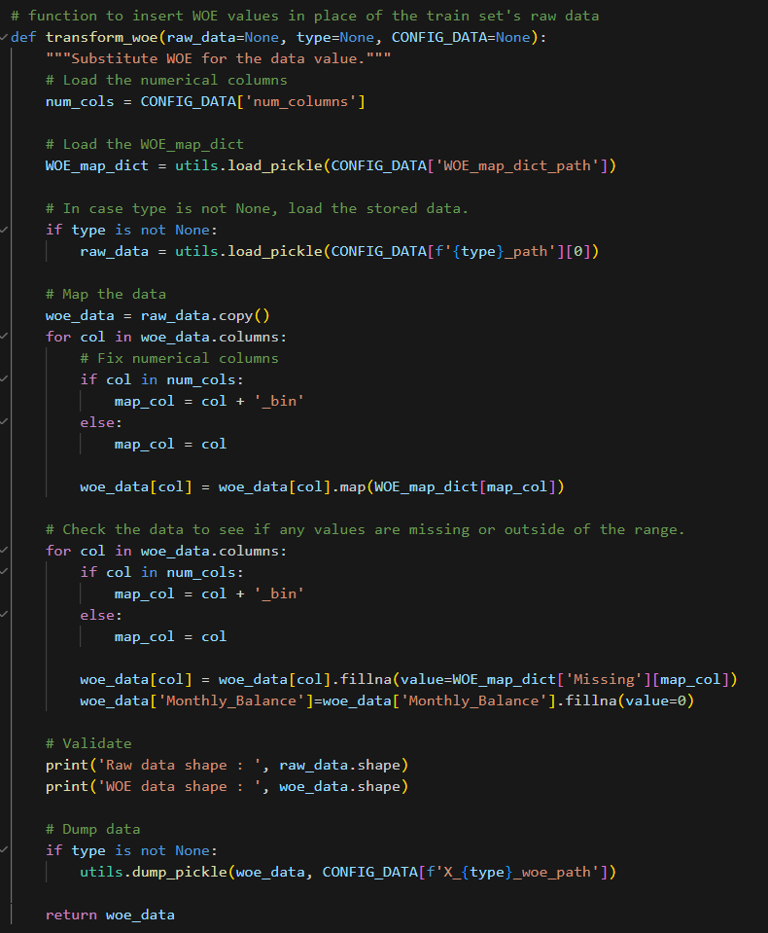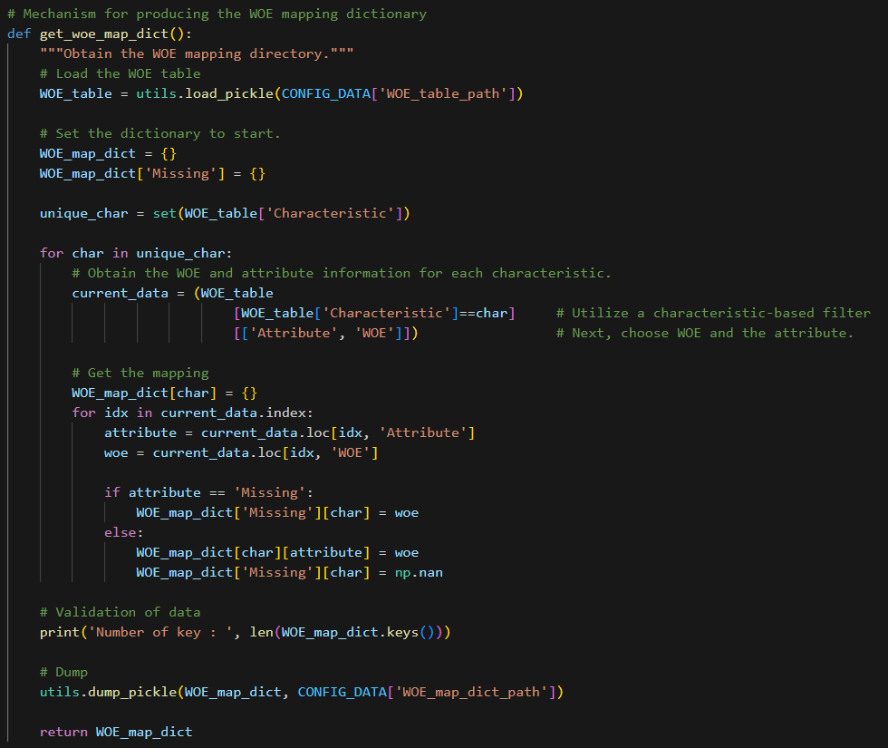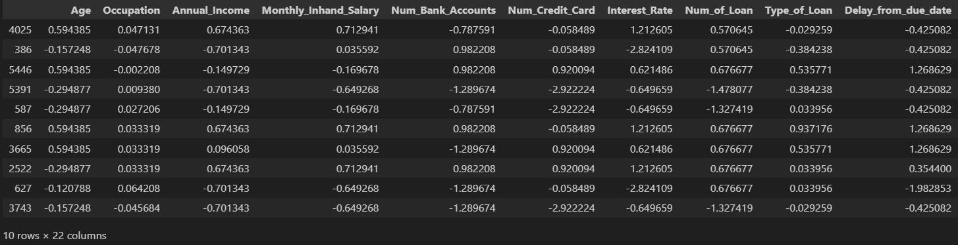

**Create WoE mapping dictionary & Insert WOE values to the train set's raw data**

1. **Importance of Business-Based Approach (Logical Trend):**
   1. **Ensuring Sensible Weightings and Scores:**

By incorporating a business-based approach, the division can verify that the final weightings and scores derived from the regression analysis align with logical trends and operational sensibilities within the banking industry. This alignment ensures that the model's outputs resonate with the practical realities of credit assessment, facilitating the development of a more intuitive and reliable credit scoring framework.

* 1. **Securing Buy-In from Internal End Users:**

The business-based approach serves to secure buy-in from internal end users, including risk managers, adjudicators, and other key stakeholders involved in the credit evaluation process. By integrating business expertise and insights into the model development, the division can foster a shared understanding and acceptance of the model's methodology and outputs, fostering a collaborative and informed approach to credit risk management within the organization.

* 1. **Validating Business Experience and Expertise:**

The business-based approach goes beyond a purely statistical evaluation, emphasizing the validation of business experience and expertise in guiding the development of the credit scoring model. By leveraging the collective knowledge and insights of industry experts and stakeholders, the division can ensure that the model's design and outputs reflect the nuanced dynamics of the credit card market, facilitating a more comprehensive and contextually relevant assessment of credit risk.

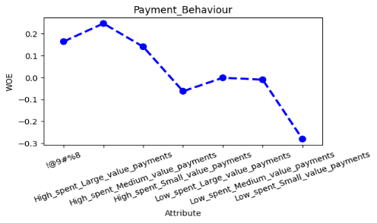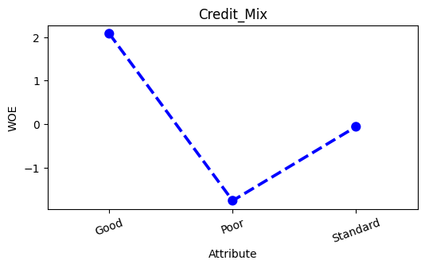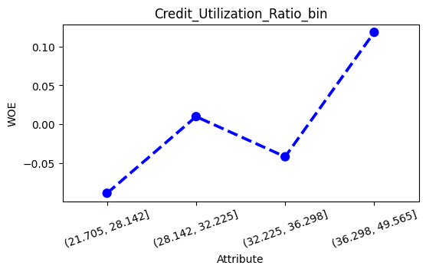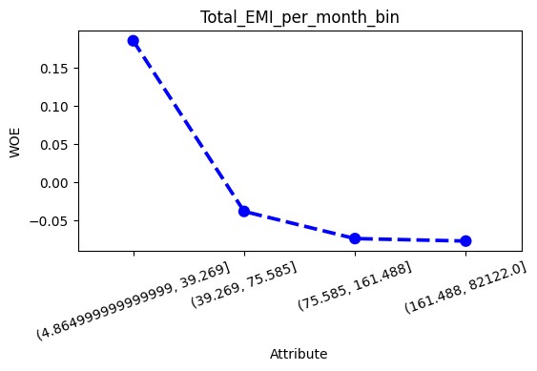

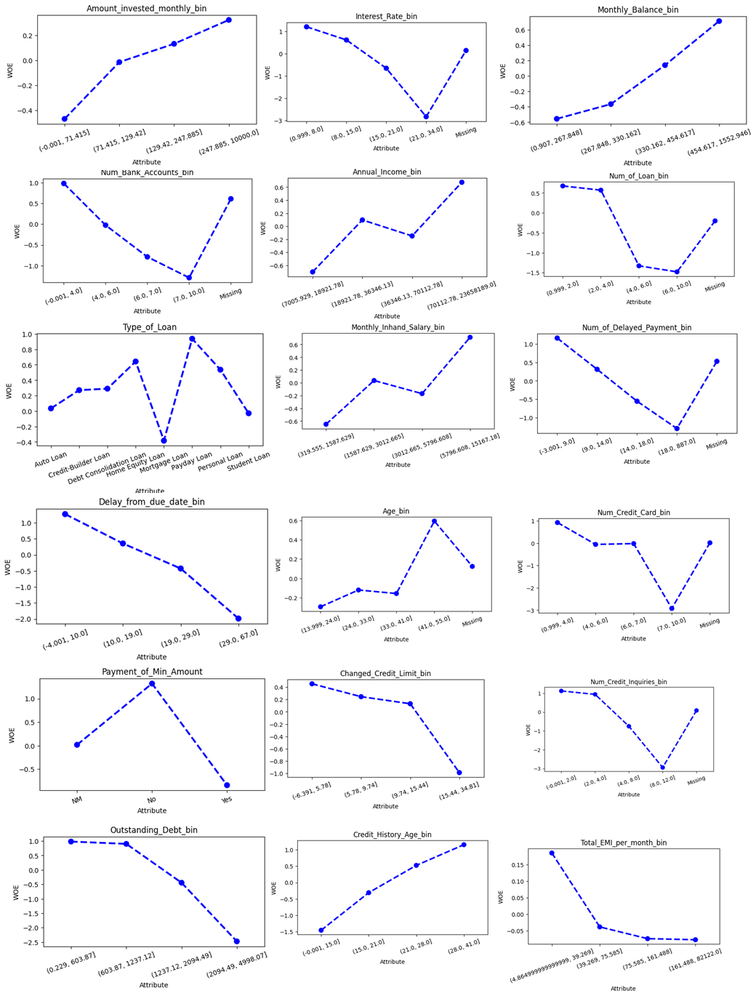

T

* **Test of Independence**

Assume that the operational/business sense and logical trend are supported by the WOE for each attribute in all characteristics. The Information Value (IV) of each trait can then be used to determine how well it predicts credit performance. Features range in their ability to predict outcomes from weak to nonexistent. Before modeling, we next determine how each characteristic and the response variable Credit_Score are dependent on one another to determine whether the weak and unpredictable trait is unrelated to the default probability.

Create a funtion to perform independence test.

1. **Design Scorecards**

All characteristics except Credit_Utilization_Ratio_bin and Occupation are not independent of the response variable (probability of default).

* + - **Preliminary Scorecard**

**Initial Model Prototype:**

The Preliminary Scorecard serves as an initial model prototype, outlining the key variables, weightings, and scoring parameters that contribute to the assessment of credit risk. This version of the scorecard provides a foundational structure for evaluating the predictive capacity of the model and identifying potential areas for refinement and enhancement during subsequent stages of model development. For this project, we use Logistic Regression model to create credit scoring analysis.

**2. Iterative Refinement Process:**

The Preliminary Scorecard undergoes an iterative refinement process, where the division continuously evaluates the performance and effectiveness of the model based on real-world data and feedback from stakeholders. This iterative approach enables the division to identify and address any discrepancies, inconsistencies, or areas of improvement within the scorecard, ensuring that the final version of the model reflects the most accurate and reliable representation of credit risk within the credit card portfolio.

**3. Alignment with Business Objectives:**

The Preliminary Scorecard is designed to align with the strategic business objectives of Amara Bank's Credit Card Product division, ensuring that the model's variables and scoring parameters reflect the division's risk management priorities, customer-centric approach, and operational requirements. This alignment enables the division to develop a scorecard that not only accurately assesses credit risk but also supports the division's broader business goals and objectives within the competitive credit card market.

* + - **Modelling**

For create credit scoring model using Logistic Regression Algorithm, we performing forward selection procedure and best model adjustment. To fit a model on the train set and determine its CV score from the validation set, define the function `forward()`. And run forward selection to do selection based one every attribute that give higher Information value.

Then, create function to fit optimal model across the entire X_train using function best_model_fitting which give return best_model, and best_model_summary with the output and functions as follows:

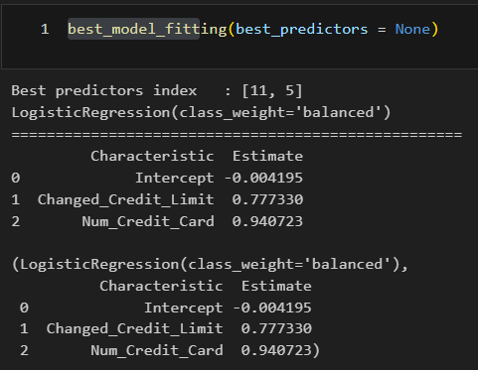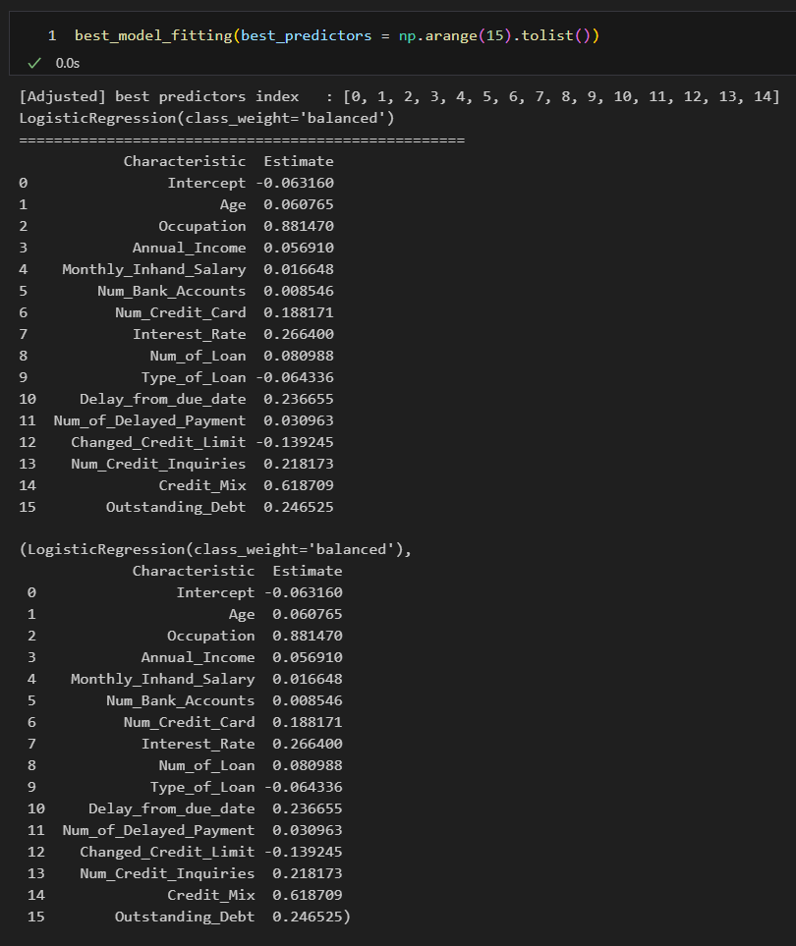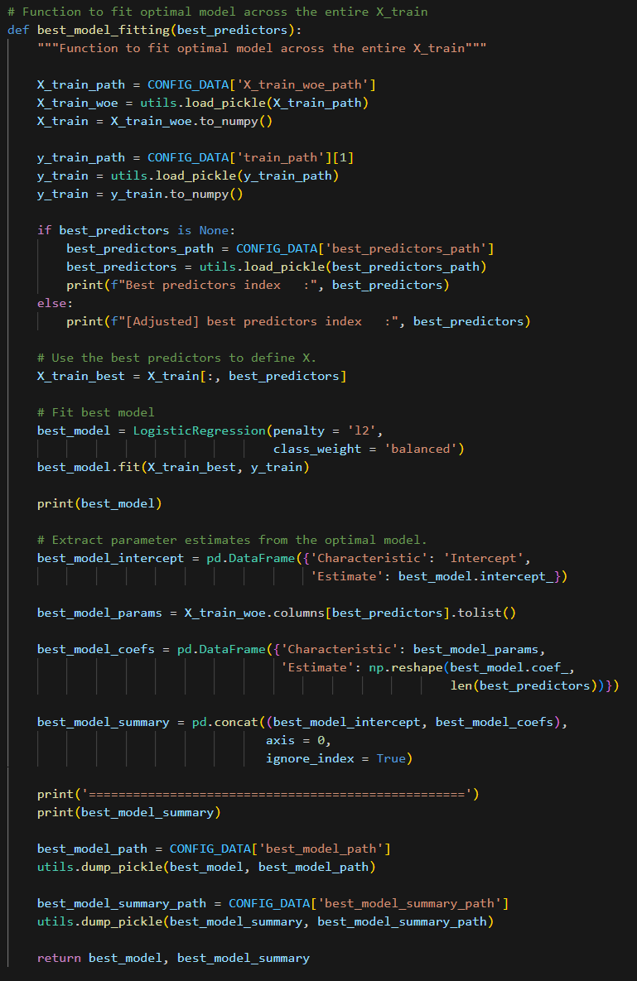

Then we can using the ROC AUC curve to see the performance of the model by AUC value and TPR and FPR rate. Apply that calculation for train data and test data to get the performance and make a comparation. Also we can use non-parametric testing Kolmogorov Smirnov to determine wether two distributions differ, or whether an underlying probability distribution differes from a hypothesized distribution

**ROC AUC Curve and KS Statistic Plot for Data Training**

* + - **Best Model Adjustment**

Too-simple scorecards typically cannot stand the test of time because:

* They are easily affected by slight alterations in the applicant profile.
* An adjudicator of quality would never base their decision on merely two features from an application form.

Every feature will be present in the finished model.

* The independence test indicates that no attribute is independent of the response variable (default probability).
* Typically, a final scorecard has eight to fifteen characteristics.
  + - **Scaling and Final Scorecard Production**

In this chapter, we’ll construct the scorecard, create the dictionary for the points map and estimate the credit score based on an input.

* 1. Create Scorecard

Give a score to each attribute by indicating: - 20 PDO (points to double the odds of good) and - Odds of good of 30:1 at 300 points score.

Thus, we can calculate the offset and factor:

Then we create function that transforms the model's output into points as follows:

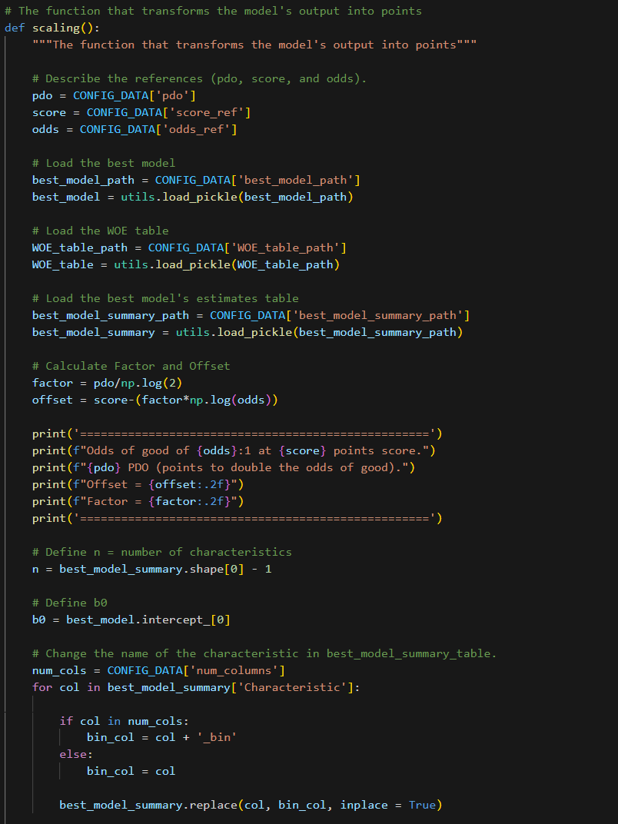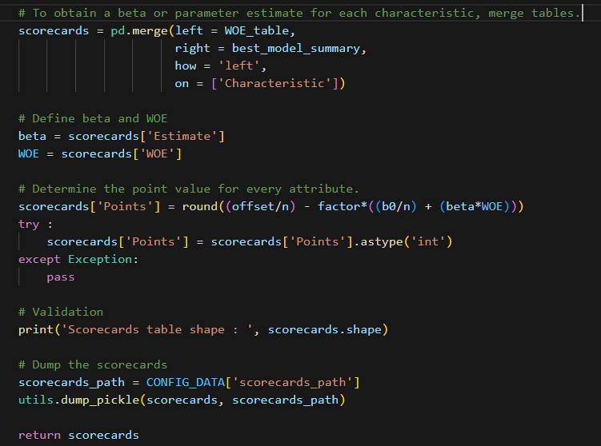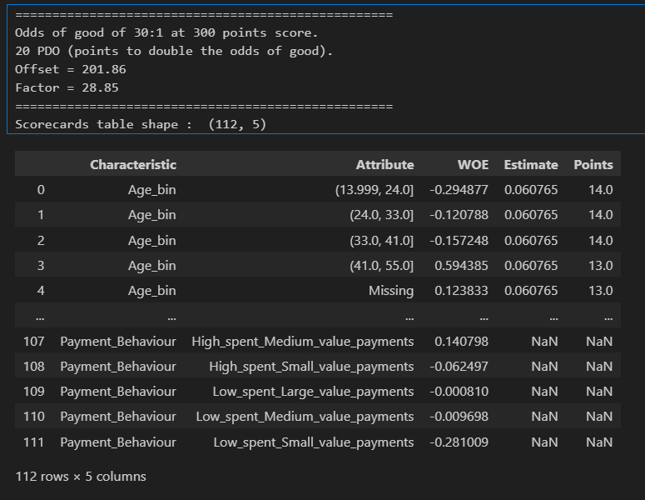

* + - **Predict the Credit Score**

In order to predict the credit score from an input, we must create the points map dictionary in this case.

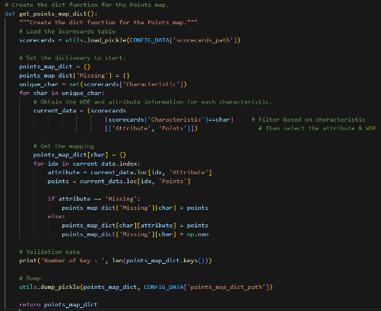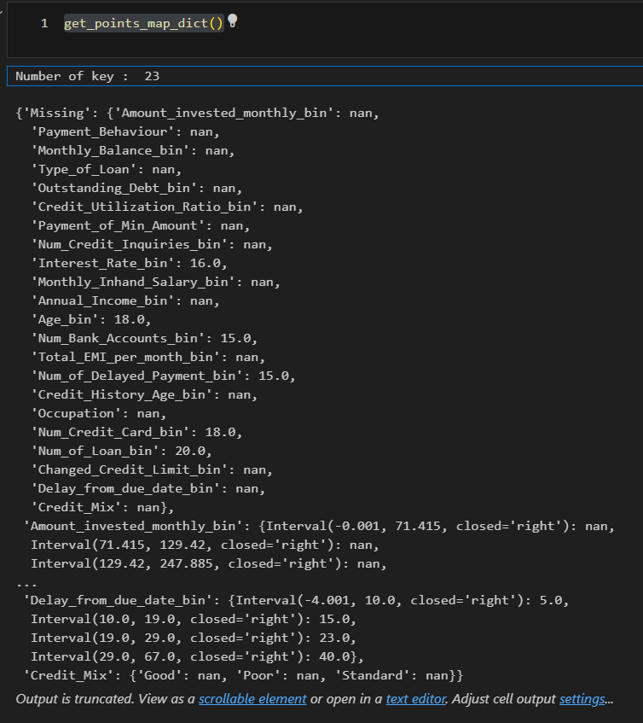

Next, convert the unprocessed input data into points for scoring.

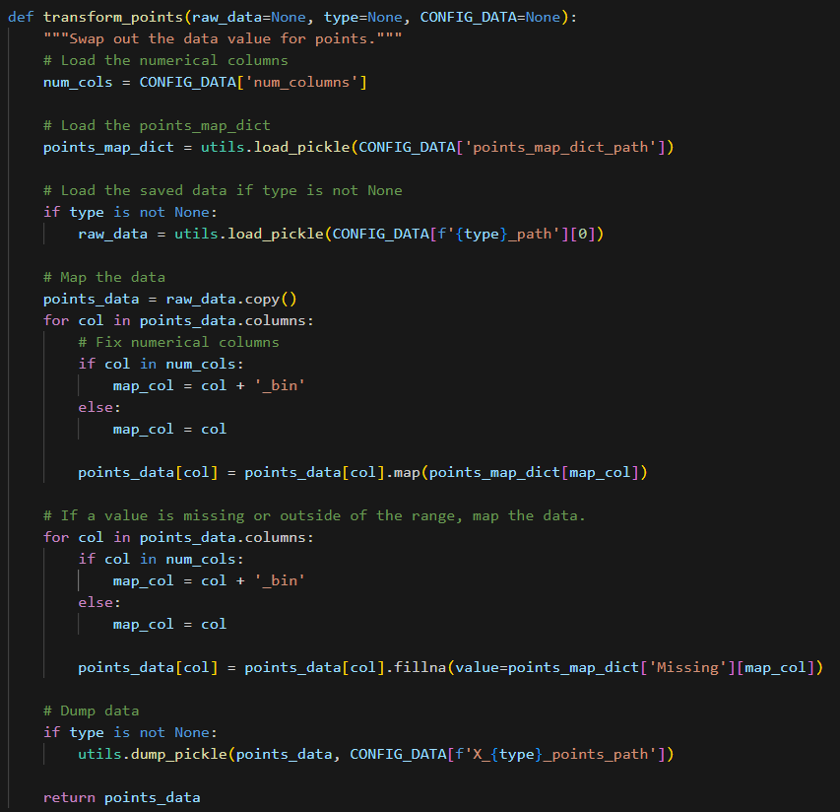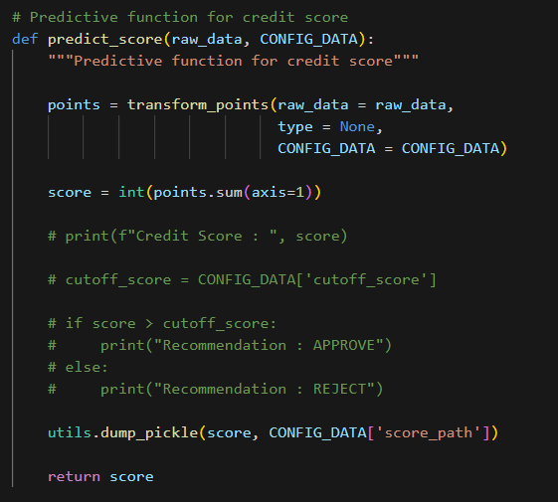

Next, include a function that determines the credit score using predict_score function and use test_input to test the machine learning model and we can get the output of the credit scoring modelling as follows:

1. **Implementation Plan**
   1. **Level of Automation**

**Initial Integration Phase**: Integrate the credit scoring model into the existing credit evaluation infrastructure, enabling seamless data flow and automated credit decision-making processes.

**Automation Testing and Validation**: Conduct comprehensive testing and validation of the automated credit evaluation system to ensure accurate data processing, model execution, and consistent decision outputs.

**Enhanced Automation Features**: Implement advanced automation features to streamline credit assessment, improve operational efficiency, and facilitate real-time credit approvals and disbursements for qualified applicants.

For more convinient, we create the user interface for Risk Officer who want to create a calculation in Scoreboard of credit scoring using FastAPI and Streamlit. For example, the applicant name Bima propose to grant the credit card in Bank Amara. And Risk Officer input the data to the apps to see the output of the Credit Score.

* 1. **Setting Credit Score Cutoff**

**Risk Threshold Analysis**: Analyze historical data and risk tolerance levels to determine the optimal credit score cutoff that aligns with the division's risk management objectives and regulatory requirements.

**Stakeholder Consultation**: Engage with key stakeholders, including risk managers, compliance officers, and senior leadership, to gather insights and inputs for setting the appropriate credit score cutoff that balances risk exposure and business growth objectives.

**Performance Monitoring and Adjustment**: Establish a monitoring mechanism to assess the effectiveness of the credit score cutoff in managing credit risk, and make necessary adjustments based on real-time performance data and market dynamics.

In order to determine the cutoff score, we require data on:

Anticipated approval percentage from:

- The most recent month or quarter's applicant distribution.

Anticipated failure rate derived from either the development sample or the most current sample

– Utilize the performance window for the scorecard.

Since we don't have access to the most recent information on credit applications,

we will:

- Calculate the test set's expected approval rate.

- Calculate the train set's expected bad rate.

* 1. **Credit Process Workflow**

**Process Mapping and Redesign**: Map the end-to-end credit evaluation process, identify potential bottlenecks or inefficiencies, and redesign the workflow to incorporate the automated credit scoring model seamlessly.

**Training and Change Managemen**t: Conduct comprehensive training programs for relevant stakeholders to ensure a smooth transition to the new credit process workflow, emphasizing the benefits of the automated credit scoring model and its impact on operational efficiency and risk management.

**Continuous Process Improvement**: Implement a continuous process improvement framework to solicit feedback, monitor workflow performance, and identify opportunities for further optimization and enhancement of the credit evaluation process based on customer feedback and industry best practices.

1. **Conclusion and Recommendation**
   1. **Conclusion from the Scorecard and Analysis:**

Based on the comprehensive analysis and deployment of the credit scoring model within the Credit Card Product division of Amara Bank, the following key conclusions can be drawn:

* + - The implemented credit scoring model effectively assesses the creditworthiness of applicants, enabling the division to make informed and accurate credit decisions while minimizing the incidence of non-performing loans and defaults within the credit card portfolio.
    - The model demonstrates robust predictive capabilities, aligning with the division's risk management priorities, operational requirements, and strategic objectives, thereby reinforcing the division's commitment to prudent risk management and customer-centric financial services.
    - The integration of the credit scoring model has streamlined the credit evaluation process, facilitating efficient and automated decision-making, and enhancing the overall operational efficiency and effectiveness within the Credit Card Product division.
  1. **Recommendations for the User:**

**Risk Manager:**

Continuously monitor the model's performance and effectiveness in managing credit risk, making necessary adjustments to the credit score cutoff and risk thresholds based on real-time data and market dynamics.

**Operational Team:**

Leverage the automated credit scoring system to streamline the credit evaluation process, enhance operational efficiency, and ensure consistent and timely credit approvals and disbursements for qualified applicants.

**Marketing Team:**

Utilize the insights generated from the credit scoring model to develop targeted marketing strategies and tailored credit card offerings that cater to specific customer segments based on their credit risk profiles and financial needs.

* 1. **Recommendation for the Next Project:**

**Enhanced Model Refinement:**

Explore the possibility of incorporating alternative data sources and advanced analytical techniques, such as machine learning algorithms and artificial intelligence, to enhance the predictive power and accuracy of the credit scoring model and further improve its ability to assess credit risk in a dynamic and evolving market landscape.

**Expanded Data Integration:**

Consider integrating additional data sources and variables, such as socio-economic indicators, spending patterns, and behavioral insights, to develop a more comprehensive and nuanced understanding of customer credit behavior and risk management dynamics, enabling the division to refine the model's assessment criteria and decision-making parameters for more accurate and personalized credit evaluations.

1. **References Works**

* Intelligent Credit Scoring – *Naeem Siddiqi*
* The Credit Scoring Toolkit – *Raymond Anderson*
* Credit Scoring, Response Modelling and Insurance Rating – *Steven Finlay*
* An Introduction to Categorical Data Analysis – *Alan Agresti*
* Learning from Imbalanced Data Set – *Alberto Fernandez, S. Garcia, M. Galar, R. C. Prati, B. Krawczyk, F. Herrera*
* Applied Logistic Regression – *David W. Hosmer and Stanley Lemeshow*
* Multivariate Data Analysis – *Joseph F. Hair Jr., William C. Black, Barry J. Babin, Rolph E. Enderson*
* An Introduction to Statistical Learning – *Gareth James, Daniela Witten, Trevor Hastie, Robert Tibshirani*
* CS 109 – Stanford University